**Analysis Data**

**Task_1 –**

**In this task, we have just collected information about count of orders on the basis of some criteria. Those criteria are –**

1. **Count of orders with profit.**
2. **Count of orders with loss.**
3. **Count of order with 0 profit/loss.**

**Then, we have plotted this information on the graph –**

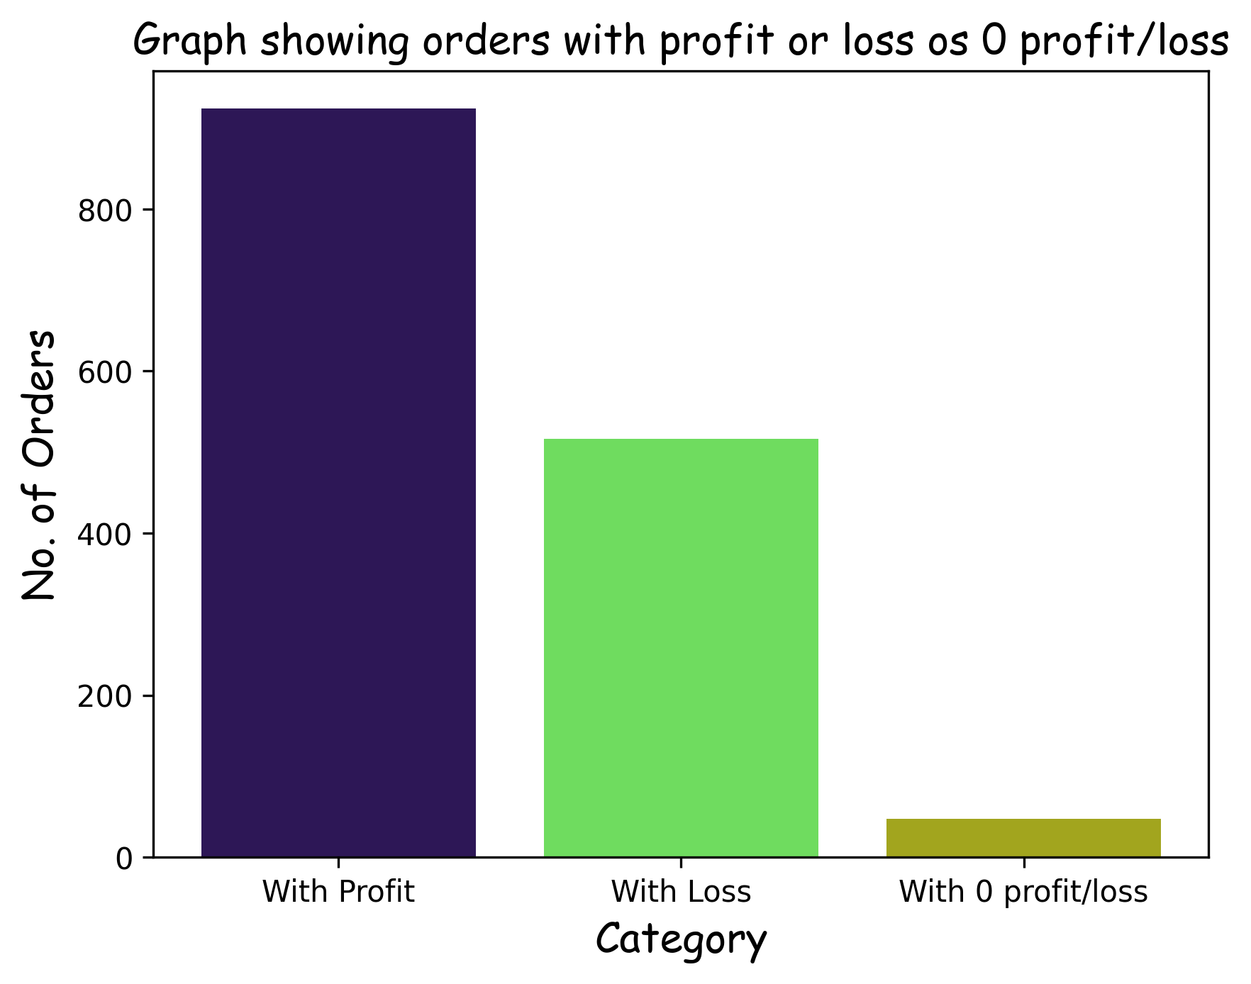

**The image file for this graph is in the folder “analysis_insights”. (Name = task_1.png)**

**Insights –**

**From this graph, we get that –**

1. **Most of orders gave us profit.**
2. **Several orders also gave us loss.**
3. **Very few orders gave 0 profit/loss.**

**To Improve –**

**Our main goal should be to decrease these loss causing orders.**

**According to me, I think the reason for several loss causing orders is the use of “gift vouchers, gift coupons, supercoins, etc.”**

**So, if the company is allowing user or customer to use these type of things, then the company can try following steps –**

1. **Decrease the amount of gift vouchers, gift coupons, supercoins, etc.**
2. **Make these things kind of ‘rare’.**

**I hope that, these steps or measures will surely decrease the amount of loss causing orders.**

**Task_2 –**

**In this task, again, we have just collected information about count of orders on the basis of some criteria. Those criteria are –**

1. **Count of orders from different categories.**

**Then, we have plotted the given information on this graph –**

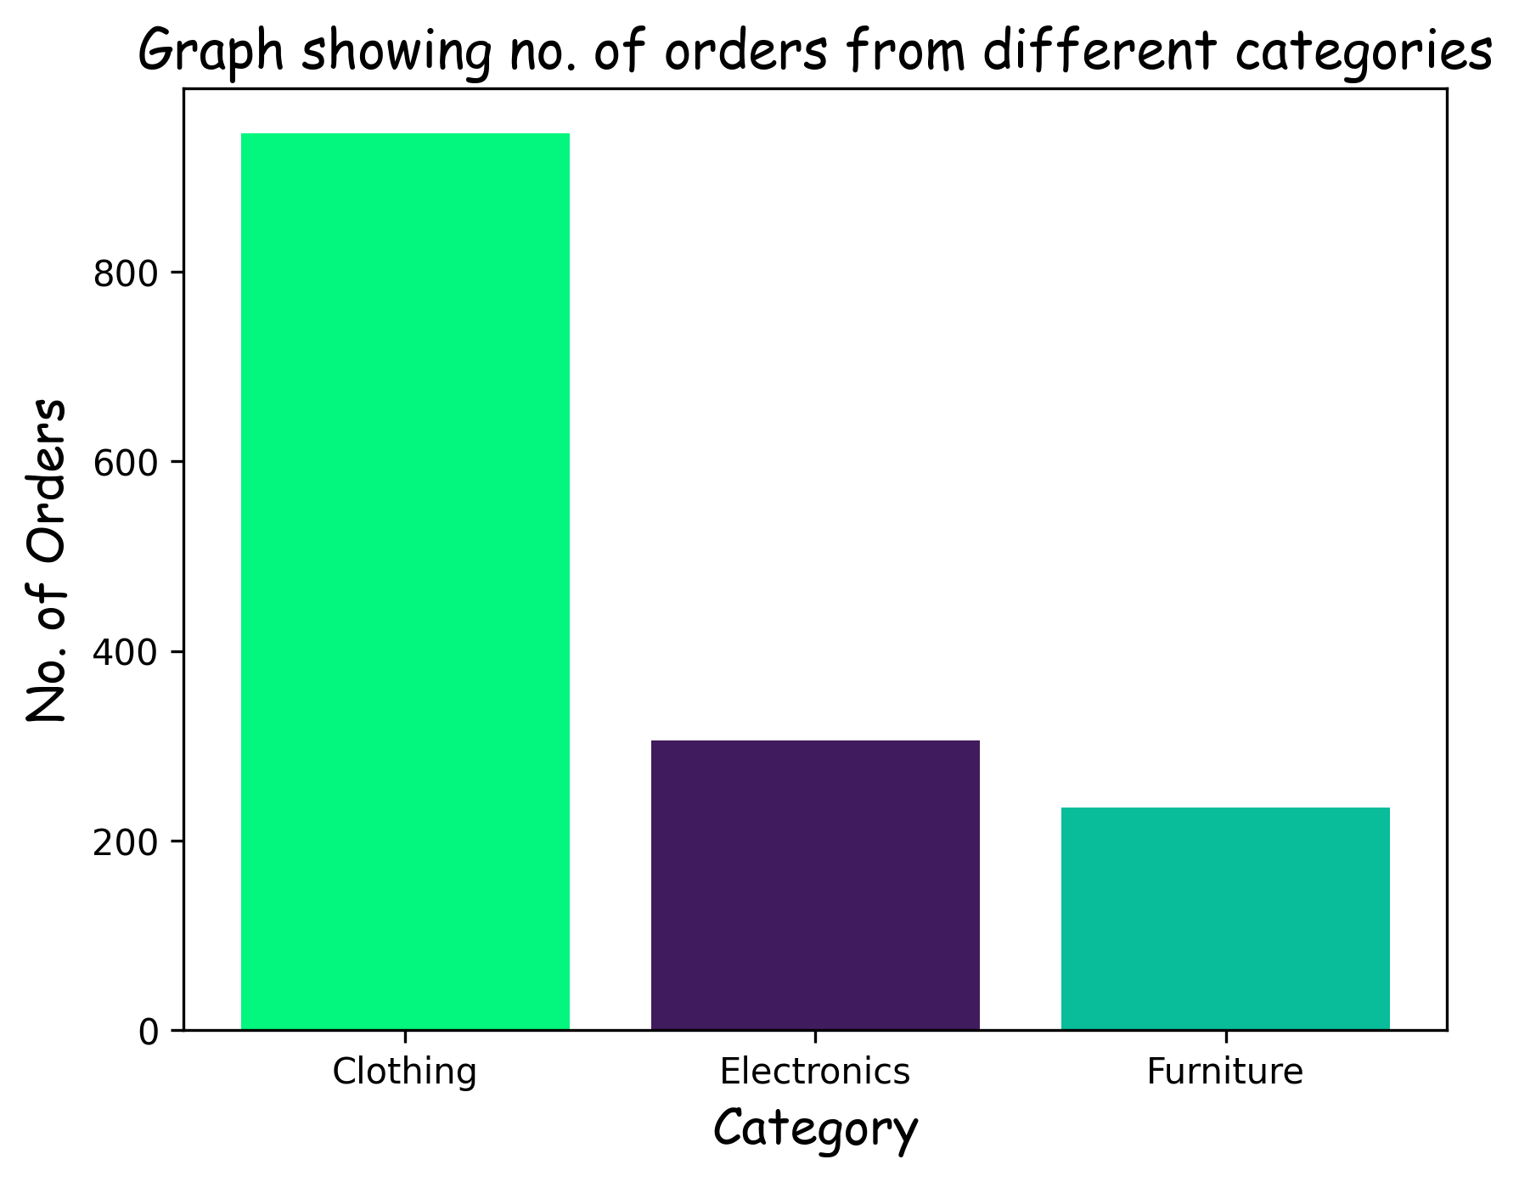

**The image file for this graph is in the folder “analysis_insights”. (Name = task_2.png)**

**Insights –**

**From this graph, we get that –**

1. **From our company, products of category “clothing” are on highest demand.**
2. **And “furniture” is at lowest demand.**

**To Improve –**

**In this case, our main goal should be to increase the sales of products of categories – electronics, furniture.**

**To do this, the company can take these measures –**

1. **The company can buy these products from well-known companies.**
2. **Provide gift vouchers, gift coupons, supercoins, on the purchase of any product from of these categories.**

**I hope that, the company will be able to increase the sales of products of these categories.**

**Task_3 –**

**In this task, we have collected the count of orders from every state. Then we have plotted this information on this graph –**

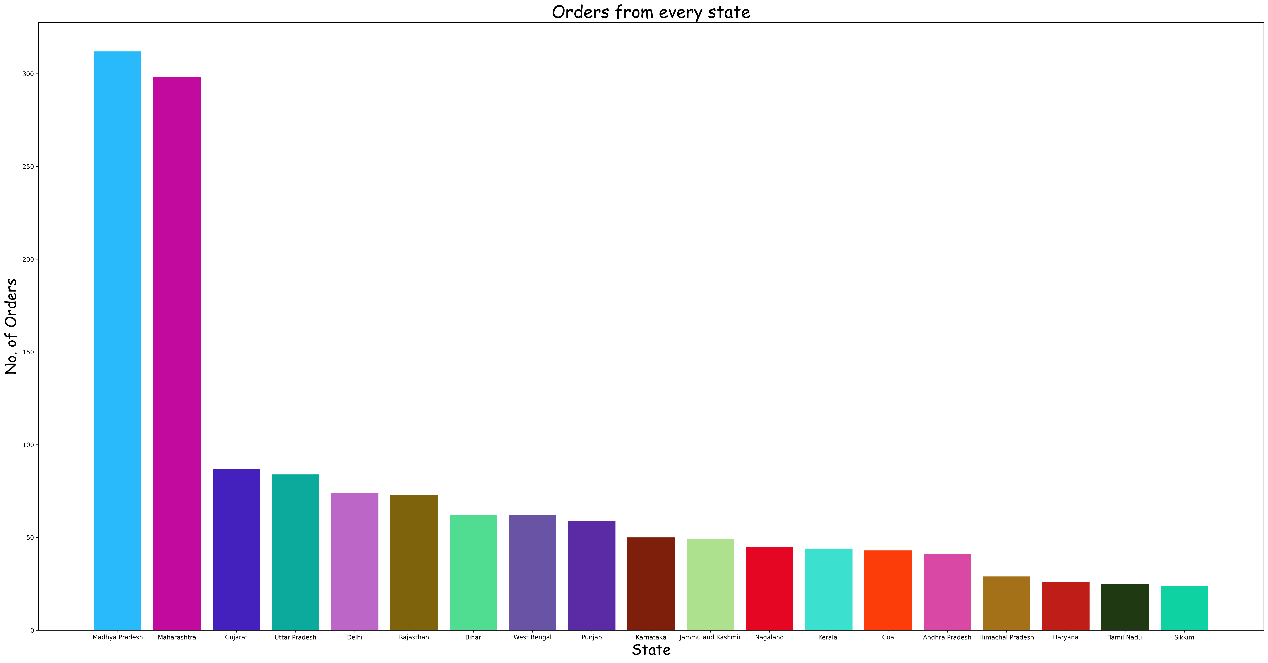

**May be this graph is blur, so prefer seeing the image file.**

**The image file for this graph is in the folder “analysis_insights”. (Name = task_3.png)**

**Insights –**

**From this graph, we get that –**

1. **The company is performing the best in Madhya Pradesh.**
2. **And the worst in Sikkim.**

**To Improve –**

**The company will have to think, how it can increase its sales in the states in which it is not performing good.**

**May, increasing the number of services may help.**

**Major Analysis Outcomes**

**As we know that we are selling products the highest in the category of “clothing”, but it is not the category in which we are earning the most or the profit is the most.**

**Refer to this graph –**

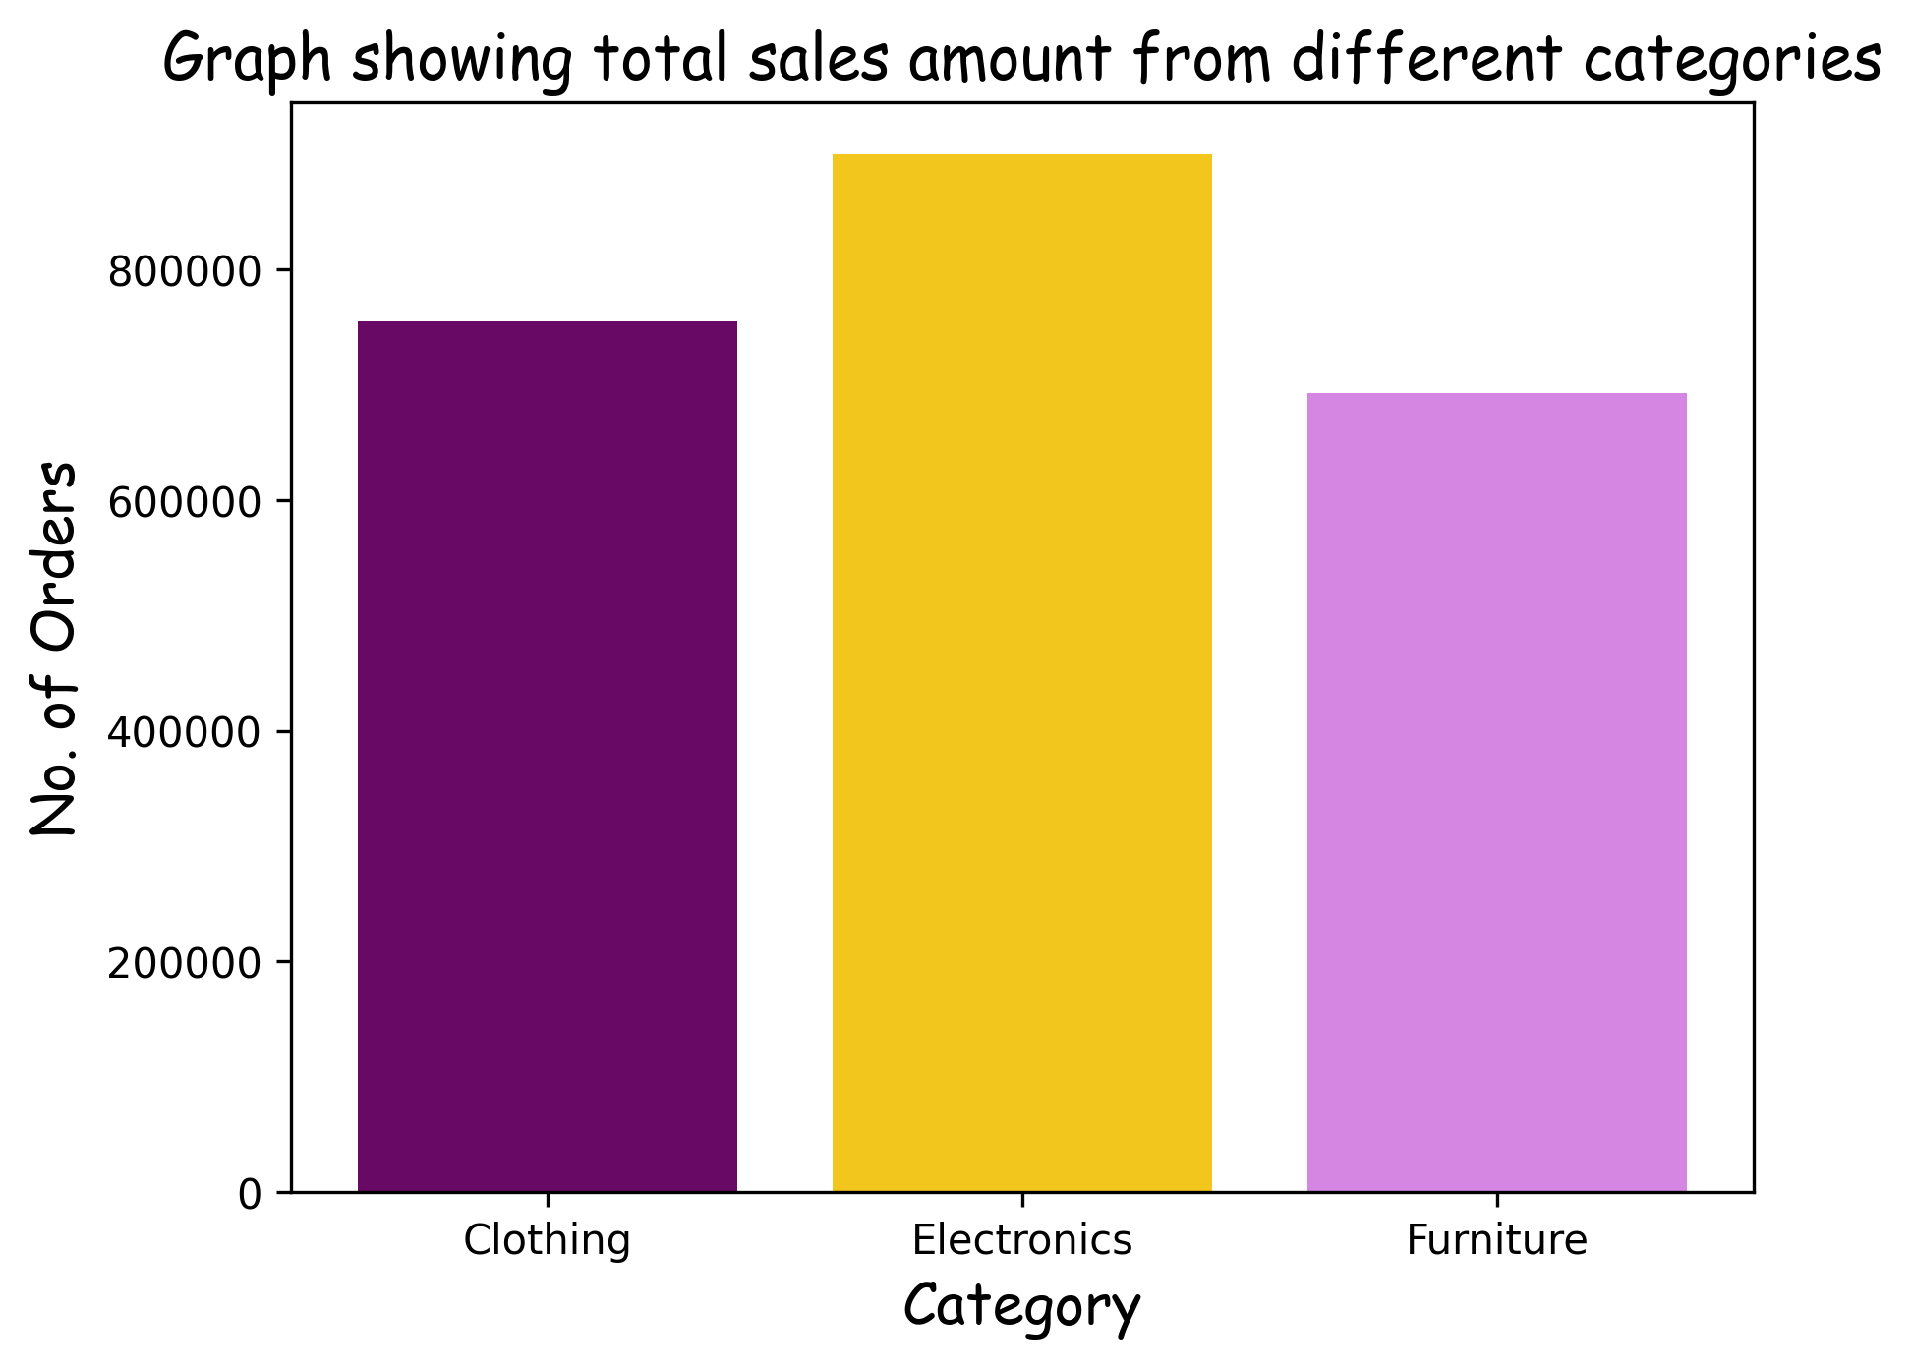

**The image file for this graph is in the folder “analysis_insights”. (Name = mja_outcome_1.png)**

**You can also refer to the pivot table in the shared Excel Workbook.**

**Now, all this means that we should increase selling prices in “Clothing” and increase selling count of products in “Electronics”.**